8.0 - Probability Distribution - Continuous Variables
2. Representing data (Chapter 2) During July, a local theatre recorded the following numbers of patrons per day over a 30-day period.
b) Determine the mean and standard deviation of these data.
Mean = $\frac{\sum{x}}{n}$
Mean = $\frac{4514}{30}$ = 150.5
SD = $\sqrt{\frac{\sum{(x-x̄)^2 }}{n}}$ = $\sqrt{\frac{21517.47}{30}}$ = 26.78
c) Construct a box-and-whisker plot of these data.
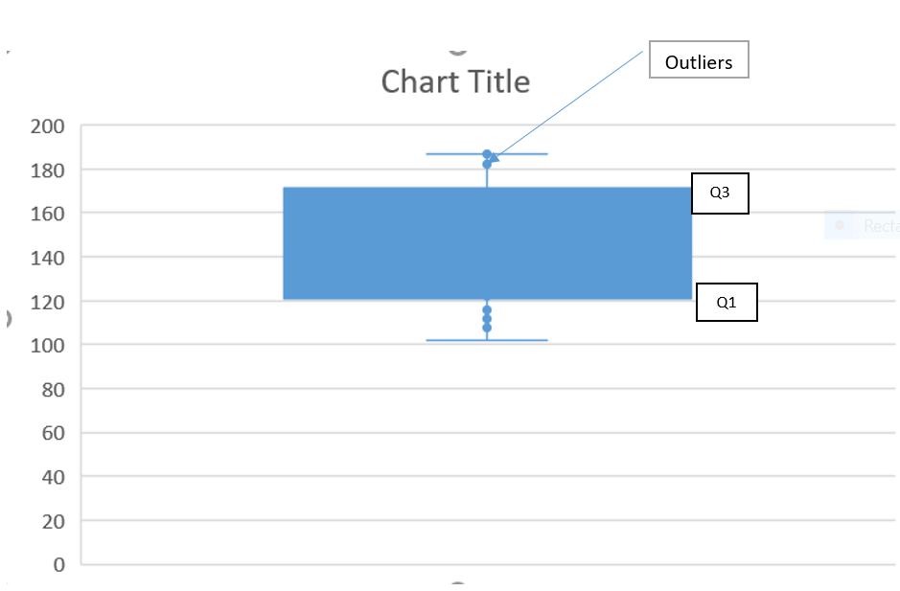
3. Summary measures for data (Chapter 2) Fifteen different cars were tested for stopping distances at a speed of 20 km/h. The results, in metres, are given below
Q1
a) Find the mean, median, and mode of these data.
Mean = $\frac{\sum{x}}{n}$ = $\frac{328}{15}$ = 21.9
Median = middle number when the values are arranged in ascending order as follows:
Median = 23
Mode is the most repeated value = 24
b) Construct a box-and-whisker plot of these data.
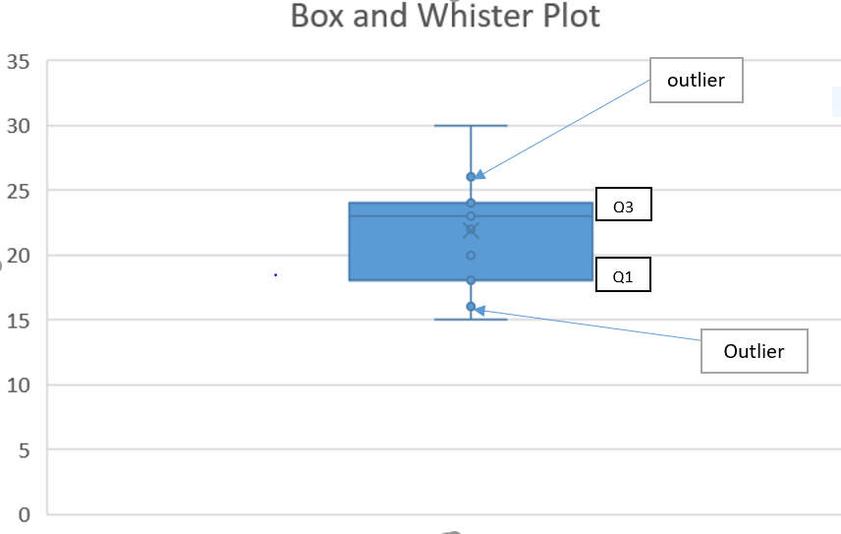
c) Find the standard deviation of these data.
SD = $\sqrt{\frac{\sum{(x-x̄)^2 }}{n}}$ = $\sqrt{\frac{249.73}{15}}$ = 4.08

4. Analyze the following data, which represent the numbers of e-mail messages received by 30 executives on a Wednesday
Mean = $\frac{\sum{x}}{n}$ = $\frac{746}{30}$ = 24.9
Median is the middle value when the values are arranged in ascending order = 22
Mode is the most repeated number = 22
SD = $\sqrt{\frac{\sum{(x-x̄)^2 }}{n}}$ = $\sqrt{\frac{6357.47}{30}}$ = 14.6
5. Summary measures for data (Chapter 2) An insurance bureau listed the ratio of registered vehicles to cars stolen for selected towns and cities in Ontario. The results for a recent year were as follows:
Mean = $\frac{\sum{x}}{n}$ = $\frac{2552}{33}$ = 77
Median is the middle value when the values are arranged in ascending order = 80
Mode is the most repeated number = 89
SD =
SD = $\sqrt{\frac{\sum{(x-x̄)^2 }}{n}}$ = $\sqrt{\frac{8905}{33}}$ = 16.43

The mean and the median of the data are close and this suggests that the data is normally distributed. This can be supported by the appearance of the histogram, which indicates that most of the values are at the center. Besides, the Standard deviation is significantly small.
8. Z-scores (section 2.6) The mean age of the viewers of a popular quiz show is 38.3 years
with a standard deviation of 12.71 years.
a) What is the z-score of a 25-year-old viewer?
z = $\frac{x- μ}{σ}$ = $\frac{25- 38.3}{12.71}$ = -1.046
b) What is the z-score of a 70-year-old viewer?
z = $\frac{x- μ}{σ}$ = $\frac{70- 38.3}{12.71}$ = 2.494
c) What is the z-score of a 40-year-old viewer?
z = $\frac{x- μ}{σ}$ = $\frac{40- 38.3}{12.71}$ = 0.1338
d) What age range is within 1 standard deviation of the mean?
Standard deviation = 12.71
Mean = 38.3
Age range = (38.3 – 12.71) and (38.3 + 12.71)
= 25.39 and 51.01
e) What age range is within 2 standard deviations of the mean?
2 standard deviations = 2 x 12.71 = 25.42
Mean = 38.3
Age range = (38.3 – 25.42) and (38.3 +25.42)
= 12.88 and 63.72
f) What age range is within 1.3 standard deviations of the mean?
1.3 standard deviations = 1.3 x 12.71 = 16.523
Age range = (38.3 – 16.523) and (38.3 + 16.523)
= 21.78 and 54.82
9. Z-scores (section 2.6) On a recent grade-11 mathematics contest, the mean score was 57.9 with a standard deviation of 11.6. On the grade-10 mathematics contest written at the same time, the mean score was 61.2 with a standard deviation of 11.9. Gavin scored 84.3 on the grade-11 contest and his sister, Patricia, scored 86.2 on the grade-10 contest. Explain why Gavin’s results could be considered better than his sister’s.
This can be explained by calculating the z score to enable comparison:
z = $\frac{x- μ}{σ}$
For Gavin, z = $\frac{x- μ}{σ}$ = $\frac{84.3- 57.9}{11.6}$ = 2.276
For Patricia, z = $\frac{x- μ}{σ}$ = $\frac{86.2- 61.2}{11.9}$ = 2.101
Gavin’s z-score is greater than Patricia's z-score, so his score is farther from the mean and is therefore better.

